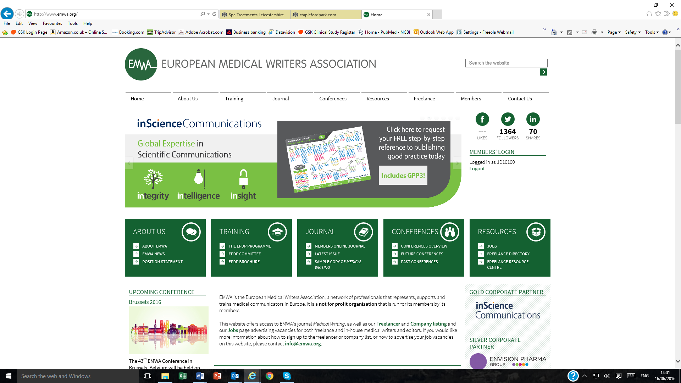

**ABSTRACT SUBMISSION FORM – EMWA SPRING CONFERENCE 2025  
Riga, Latvia**

Deadline for abstract submission: 25 January 2025

|  |  |
| --- | --- |
| **Presenting author**  *First name, last name, telephone and e-mail* |  |
| ***The presenting author is the single contact for all correspondence*** | |
| **All Authors**  *First name, last name and affiliations* | ***Underline the name of the presenting author*** |
| **Abstract Title**  *Maximum 20 words* | ***This should be brief and indicate the content of the abstract*** |
| **Abstract body**  *English language (UK spelling)*  *Maximum 250 words* | **Introduction**  **Methods**  **Results**  **Conclusions** |
| **Presenting author signature\*** |  |
| **If this is an encore abstract submission, pls indicate where the original abstract was previously presented** |  |

*By signing this *Abstract Submission Form*, I confirm that this is original research that has not been previously published as a full paper. All authors are aware of the abstract, have made a significant contribution to its development, and agree to its submission.